Facebook system design

**Objective :**

How to design a social n/w like facebook. Now the same system can be used for any other social n/w

Like Instagram , linked in or twitter.

**Let looks at some functional and non functional requirement :-**

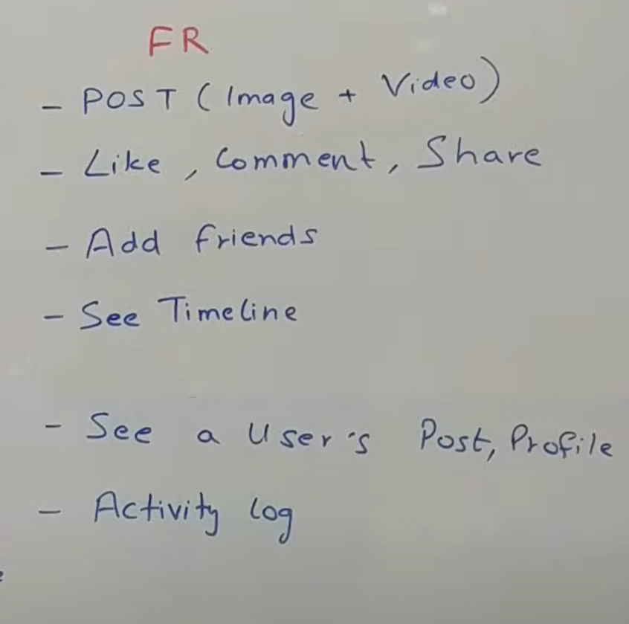

From the functional requirement the very first point we should be able to post and make a post.

**Post** is anything that we want to update on the platform. It could have a image. It could have a video. It could be text.

We should be able to **like** a post, **comment** on a post , **share** a post.

The next thing is **adding a friend**. A person should be able to go somebody else profile and add as a friend.

The next thing is **user should be able to see timeline** . let I have 100 friend posted something whatever they wanted to I would see all of that data in my timeline.

User should be able to **see other post and other profile.** Other profile mean timeline of a particular user.

**Activity log** : user like something , comment : all of that should be tracked and visible somewhere

NFR

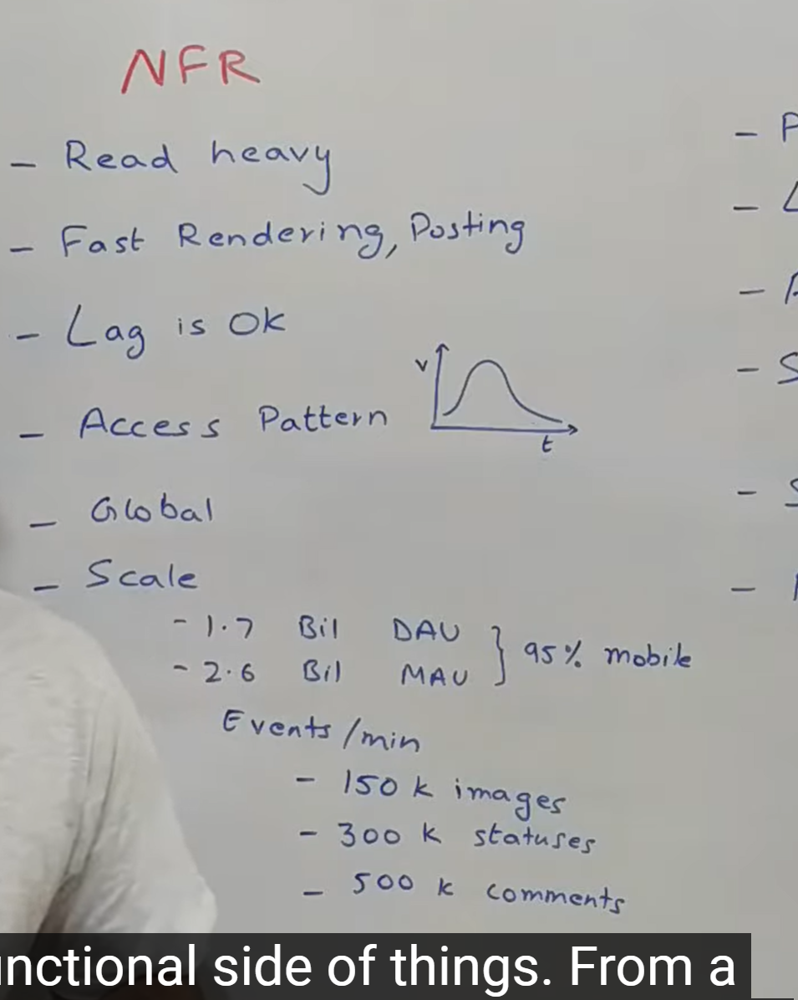

From the NFR we know that any social n/w is very **read heavy system**.

Let say if I post it then all of my friend are seeing it so there is one write and probably 100 reads.

It should have very **fast rendering and posting time** whenever I m seeing somebody comment and profile all should be render very quickly.

**Some lag** is ok let say user post something and friend see after 10 or 20 second it ok.

Any social n/w have very **unique pattern** so whenever post is created it getting lot of views, comment slowly after two week there is no interaction with the comment.

**Global :**  the platform should be available in multiple language and should be able to handle content in multiple language.

**Scale :**

1.7 billion unique daily active users

95 percent of people access through mobile phone. So we need to do **some optimization** that are very specific to mobile phones

**Every minute** : upload 150 thousand images which need to uploaded onto our server spread out in various CDN

**Here because of huge number of volume we might not be cache everything so there is some changes will do from twitter design.**

**We**  have categorized user into fiver segment.

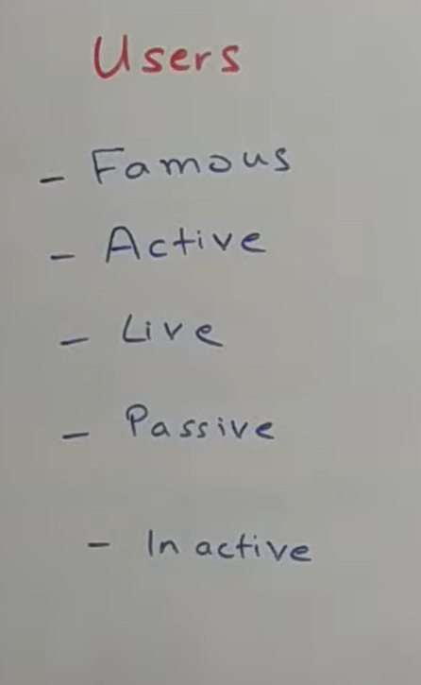

**Famous user :**  are user who has huge number of friend.

**Active user** : who access fb in last few days

**Live users :**  who actively browsing the platform right now.

**Passive user** : are those user who not regularly active so we will not cache information for them

**Inactive user :**  deactivated account.

**Now lets go the overall architecture**

Overall architecture divided into multiple component :

**Bit of convention**

Thing in **green** are user interaction point. ( web browser, mobile application).

Thing in **black** are load balance, reverse proxy, authentication and authorization which will validate the api call coming from outside world into our system.

Things in **blue** are web service that we have written. It could be kafka consumer , sparks jobs

Things in **red** are d/b , data store any cluster like kafka cluster, Hadoop cluster or any third party tool like CDN

**Let start with user flow on how does the user come into the system**

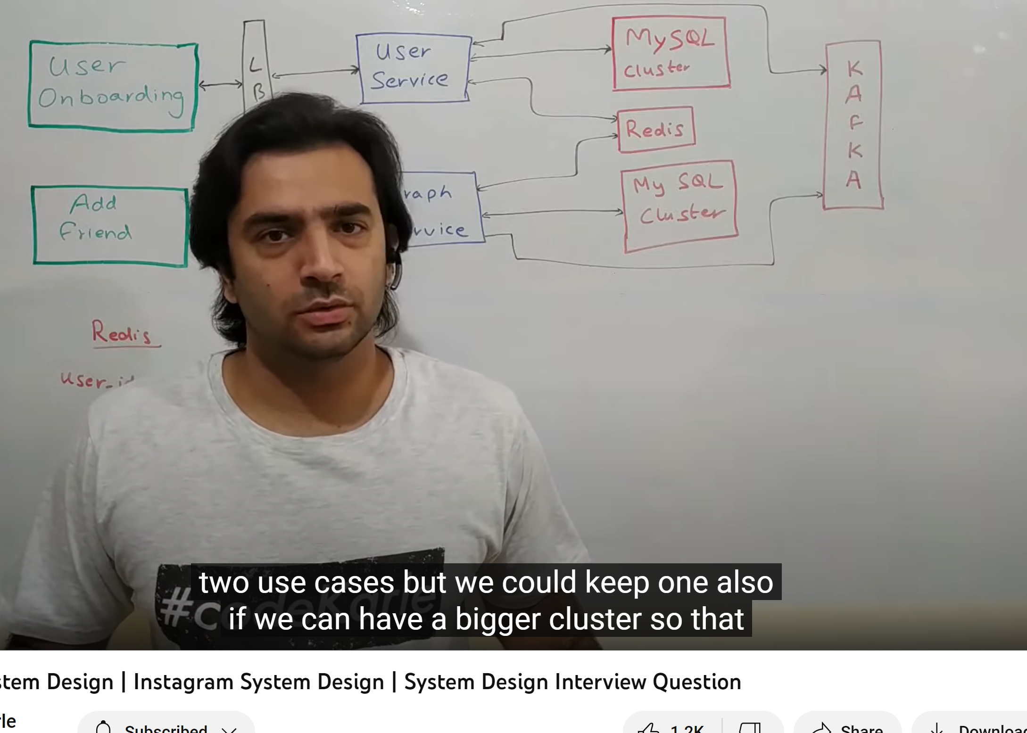

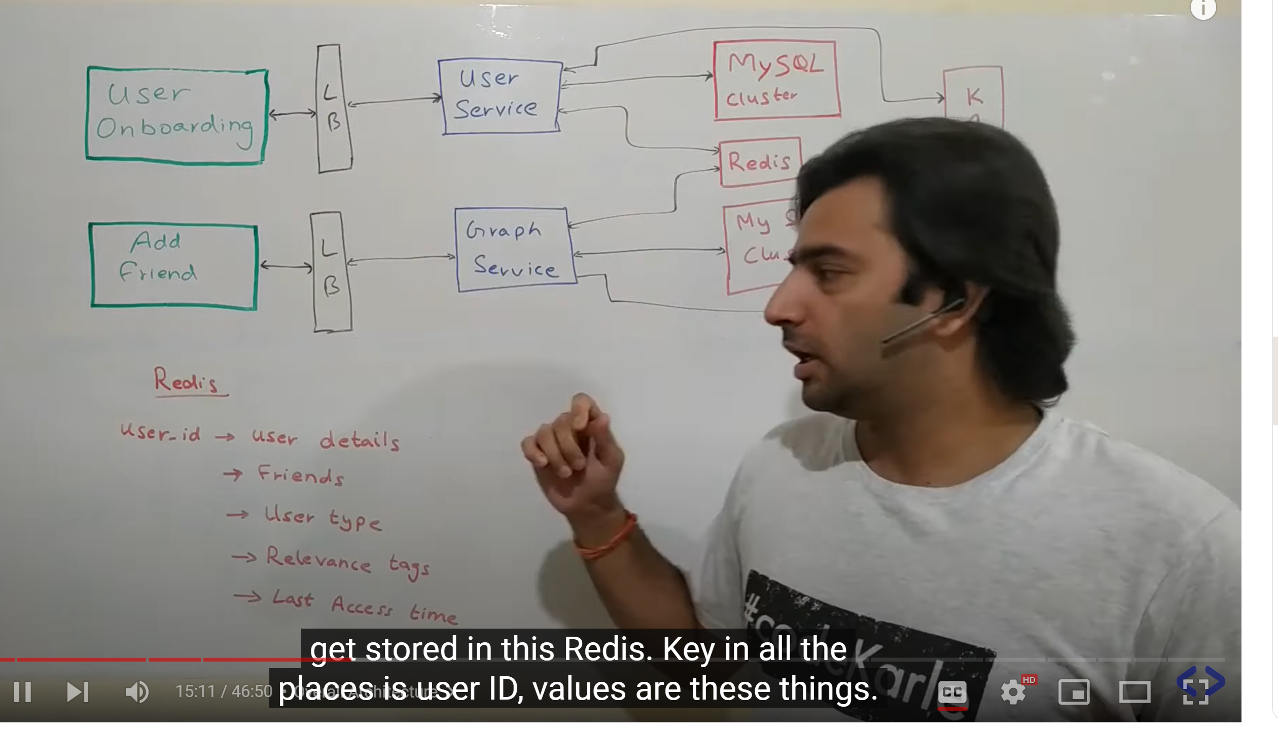

**This**  is very similar to twitter design.

**User onboarding and login and user interaction** like looking at profile , creating profile updating their profile are basically this green box **( user onboarding)**  and all of that is taken care by **User service.**  User service is the primary source of data for any user information. It provides all the api that the UI need . these would generally API to get a user by User id , update user by user id , get details of lot of user in bulk. Now this user service sit on top of **clustered mysql**  because user data is very standard and it is not updated very frequently. Now user service is also sit on top of **redis.**  It basically caches a lot of information so in redis all the user info will be there. Let see we need to fetch user details of user it will first see in redis and if doesn’t get it will get from mysql update the redis and return back to the user. **When user logged in or account get created and event is pushed into kafka**  for lot of reasons. So let say update user we want to notify to notification service so all would be taken care by **kafka**.

**How does user add someone as a friend**

User can go someone else profile and add them as a friend all of them taken care by **graph service**.

Which user connected to which all people graph service will expose API for all those functioniality.

Graph service also sit on top of clustered mysql d/b .

All the user r/s would be stored into redis .store into redis like key is user id and balues is list of friends.

**Now lets look how does a user post some comment and how do they retrieve from their timeline and other user post**

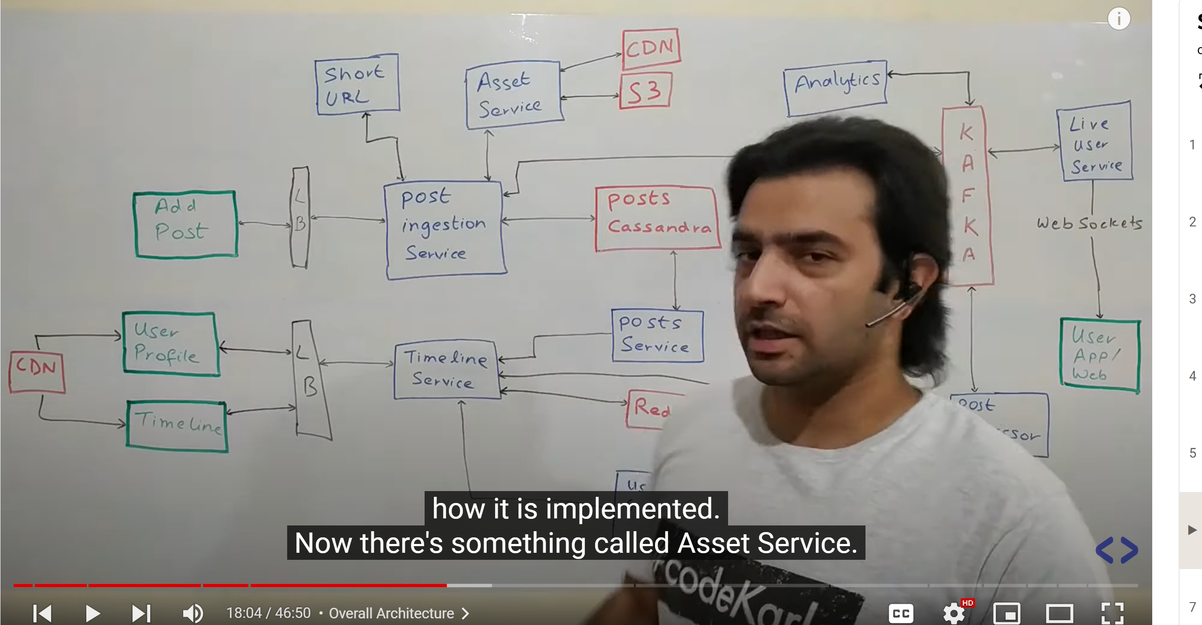

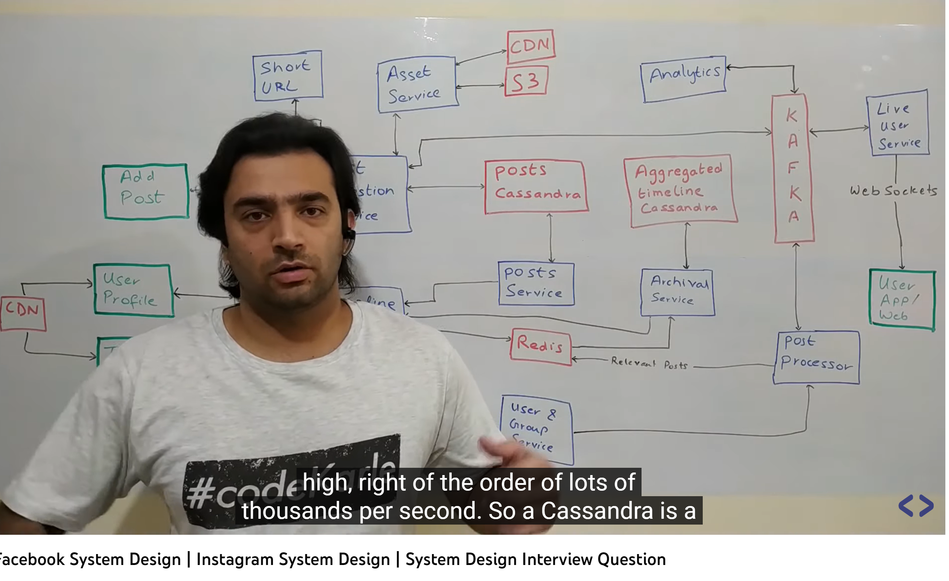

First look at some of the generic component that we are using here. So there is a component clled **shortUrl** .let say someone posted URl into fb then it will convert into short URL and a person click on it then it will be redirected to long URL . Now there something called **AssetService.**

It does make sense to reduce the aspect ratio (seeing in mobile and in browser) and the number of pixel in the content there so all of those pieces are taken care by Asset service :- this is basically video serving platform . it takes care of file conversion to multiple format to multiple bandwidth.

So once the pic upload and after a month view will be less then will removed by CDN and stored in s3. So we are using s3 for image and video store here. So again if famous personality comment on pic it will be pull from s3 and put into cdn wherever it is getting accessed from. **So this is basically video/ image streaming optimization to take care of geographical data.**

**Now let try with user flow when they try to post a content.**

So that is taken care by **add post** box . it talk to something called **post injection service.**

Now if it has audio/video content post injection service will talk to asset service. If it has url it will alk to short URL service. And then it will has final content that will actually need to persist. Now for all post kind of data I m using **cassandara** here. It can handle both write and read part as volume od data is huge. Once the post is saved into Cassandra there is a service called **Post service**  and this is the service which will provide to everybody else to access a particular post. Basically if we want to get a post by id or get a lot of post by lot of ids all of those api are provided by this post service.

**Now whenever post come post injection service read the post put it into Cassandra and then post an event into a kafka.** Not there is a **analytics** it is not a service . it is lot of component so on this kafka there will be a streaming consumer which will keep listening to all the event that are coming in and it will try to tag it using a machine learning model saying that this post is what kind of cateogary. Now once analytics cluster tag a particular post it put back into kafka from where it will be processed further who are the right user who could see this post**. So once analytics put back it into kafka there is something called post processor**  which runs. Now this post processor basically look at the content of so it get event from kafka which has the content of post and some tags along with that and user id who posted the content. It then queries **user service and group service. So**  this post processor will fetch all the friend of this particular user who potentially can see this post .

It then put all the relevant post( subset of user who can see this post) into **redis . it**  basically is timeline of all the user. Once the post is into redis now the post processor job is done.

Now coming to other side of thing what happens when a user access a particular their timeline. So there are two kind of timeline that a person can see**. One is user want to someone else profile and they want to see all their post** that is very straight forward it basically calls timeline service I want to see all the post of this particular user. Timeline service would query the post service saying give me all the post of this particular user and display it back. **The other side of thing when they want to see their own timeline**  which basically contain post of all their friend. Now timeline box will basically call timeline service which then does a lot of things . it will get all the timeline from redis for that particular user

**Now we can do lot of optimization for live user**

**Post processor**  will came to know when it call group service so along with sending into redis it will post event into another topic of kafka saying **this user is live and**  this is timeline he needs to see now with this new additional content somebody go and give the info. Then comes the job of live **user service** . it is basically a service which has open connection based on web socket with all the client (users) so these are your regular user who using mobile app and this service has open connection with all the user. Now whenever this service will get a particular event saying this user view need to be updated it will send the event to the app via websocket protocol and the app would show the new post in whatever way it need to so this will do for live user.

Now there is something called **Archival service so**  what it does is so the redis cannot contain data for a lot of period of time we will put only today data into redis all the post that have come in today.

For everything in the past we will use something called **archival service. So**  what archival service do at some point of time in a day it fetches all the users timeline whatever have been created it posted into something called an **aggregated timeline Cassandra**  and clear this cache. Now we have finite amount of data into redis which is small. We are just storing post id and not the actual content to get actual content will use **post service**

**Coming to last section of this video let talk about how are likes and comment handled**

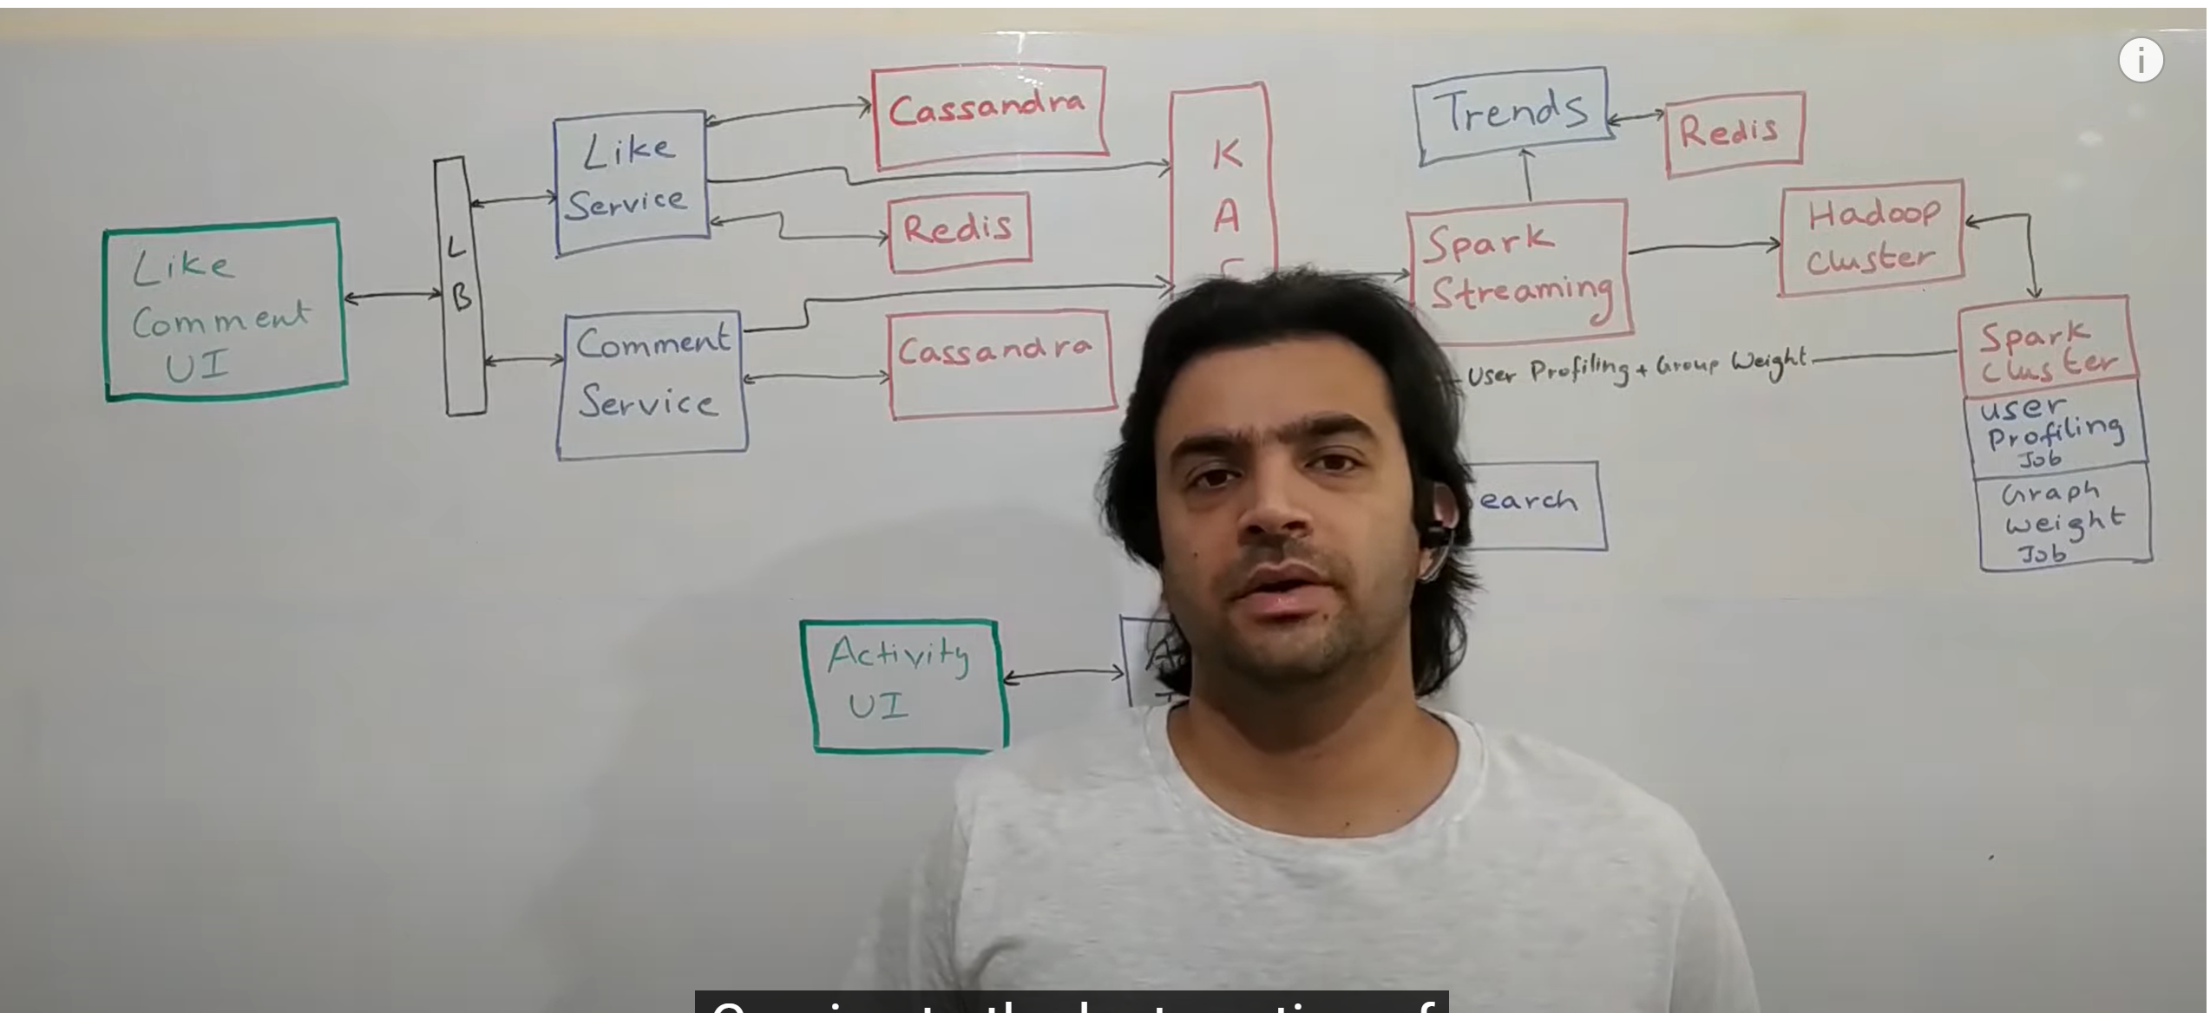

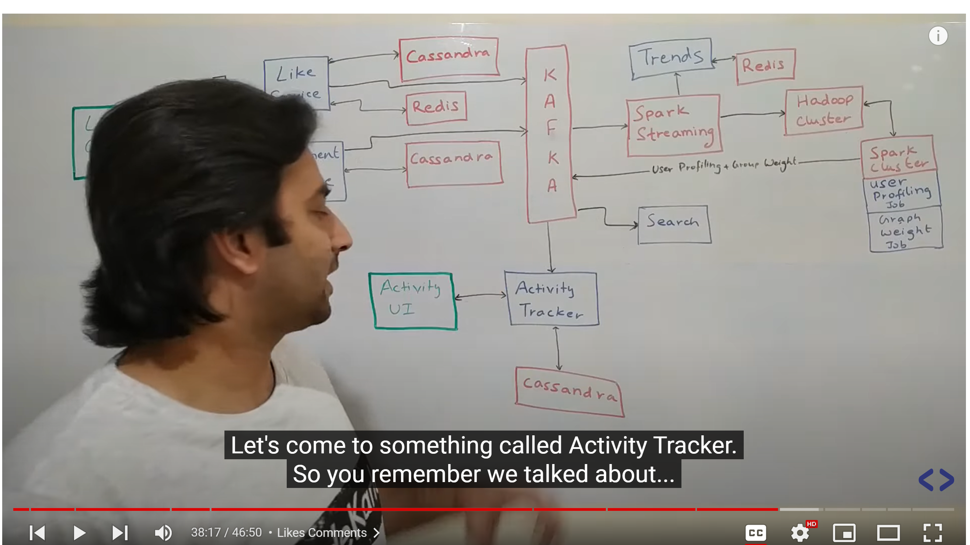

So asuming there is **UI** which people can do a comment or like . this could come through various devices like phones , browser whatever etc. so whenever user presses a like button the request goes to this **like service now**  this like service is the owner of all like information. So whenever we put a like or get a like all are powered by this like service. Now whenever a person add a like that info get stored into **Cassandra** . think as of table saying user id and post id so post id contain the post which is being like and user id is basically the user who liking it. So that is permanent store but there is **redis** also use so basically along with post content number of likes also shown so number of likes is being powered by redis. Once the post becomes outdated this particular entry will have some **TTL ( time to live) of**  a few days and that will get expired. But for all the recent post it should have info of count. So whenever a likes comes into system it get stored into Cassandra and redis update get called . now once a like has been posted that information would also be put into kafka saying this user has liked this particular post. How that will use will come into a while. Now lets go to **comments. So**  again there is something called **comment service which**  is basically the repository of all the comment into the system whether you want to make a comment or get all the comment of post that will be powered by this service and this uses a Cassandra as a datastore. A very simple schema it will have a post id and a comment text and whenever we want all the comment we just need to run where clause on post id.

**Now we did now talk about sharing of post earlier**

**Sharing**  of post is exactly same as post is implemented . now whenever comment is added it also posted into kafka for further analytics. Now let come something called **activity tracker.**  We want to capture all the activity that is done by a person on FB. Let say person makes a post or like a post all of that would be tracked. Anyways all those info are coming into kafka like post , likes, comment all we need to do (activity tracker) is to store that information against a user id with the timestamp that this was the action taken so all of these will be powered by activity tracker. This will have both insert APIs into Cassandra and gets API to fetch the data from Cassandra and show it to on activity UI. This activity tracker would listen to the same topic that everybody is writing to. Now coming to **search. Search**  is implemented in exactly the same way as it was in twitter . so assume if all the events coming into kafka there is **search consumer**  **that**  reads all those event store it into elastic search which is very efficient for text based searching and there is **search service**  that sit on top of this elastic search run the query and return the data and in some cases we might want to cache the result of search response so before sending it to the user we might cache it into redis as well. And while searching that information is also get pushed into kafka so that can be logged by activity tracker. So we put a lot of information into kafka saying that we will do some analytics.

**Lets take some example what kind of analytics can be done**

**So**  let say person post a content that content can be classified using some very standard classification ML algorithm into certain tags. So for example post can be tagged as sport related post. So a person is having lot of sport tag that show that person is interested in sport so what we will actually do is you will have spark **streaming consumer** running which will put all the info about all the activities and by user into this **Hadoop cluster**. That would include post, comment ,likes. And then we will have some algorithm which basically do this user profiling saying if a user is liking a lot sport related post that means person is interested in that if a person comment on that that also same means so all of those information could be used could be used to generate a **user profile** which classifies user interest. Once a user profile is created that is put back into kafka and **user service**  which was storing a user profile tag kind of thing. User service basically read that event and stores those tags against the user which is then used for various kind of things in the system that we talked about in that section too. Now there is something called **graph weight . let**  say me and modi are friend , I like his most of the post but he don’t like so that info is stored in graph weight job base on post it will create a profile saying I m more inclined with these people and less inclined with the remaining one. Now this run on top of spark cluster can query a Hadoop. Now we have left something called **trends. It**  basically tell us what people on FB talking us right now. Basically what spark streaming job will do it takes all the post, comments , tokenize them , split them by space character remove very common stop words like ,’a’ , ‘of’ , ‘the’ and then remaining word will put into **trend service** stack ranked by their count so at any point of time will know what word is the most used word right now and all of those information could be stored into redis cache.

So there are diff technology use here and we need to do lot of **alerting monitoring**  on all of these things. So let say a web service is build we need to measure cpu usage , disk memory and if anything spikes up then we need to send out an alert. Similarly for all the d/b we need to keep a track on how many what are the throughput and latency are how many queries are getting executed what is the disk space we don’t want a d/b disk to be full at any cost so all of those on the caches, on the web server on kafka all of these those thing need to be monitored on and as soon as they go beyond a particular threshold there need to be some good enough alerting so that the people get to know something is going beyond limit and can look into it proactively.